

ADVANCED SOFTWARE ENGINEERING

PROJECT DESIGN AND REPORT

*Presented by*

Group – 6

Abstract

Acknowledgement

INDEX

1. Introduction
   1. Overview
   2. Project Tasks
      1. N-Queens Problem
      2. Polysphere Puzzle: 2-Dimentional
      3. Polysphere Puzzle: 3-Dimentional
2. Development
   1. Development Methodology
   2. Software Tools
   3. Design Plan
   4. Implementation
3. Testing
   1. N-Queens Problem
   2. Polysphere Puzzle: 2-Dimentional
   3. Polysphere Puzzle: 3-Dimentional
4. Conclusion
   1. Limitations
   2. Future Enhancements
5. References and Bibliography

INTRODUCTION

*Overview*

This comprehensive report unfolds an in-depth study and analysis, delving into a purposeful software initiative aimed at the development of web-based game application. The primary objective of this application is to engage users in the interactive exploration and resolution of puzzles, specifically focusing on the N-Queens puzzle, the Polysphere Puzzle in a 2-dimensional grid, and the Polysphere Puzzle in a 3-dimensional pyramid. The central emphasis of this web application development project is to empower users to independently engage with and solve these intricate puzzles.

This web application is developed to offer users the capability to actively participate in the puzzle-solving process. It is designed to let users navigate through the N-Queens puzzle, strategically placing queens on a chessboard, and tackling the Polysphere Puzzles in both 2D and 3D environments by placing different shapes on the grids. Furthermore, the application is equipped to present solutions to these puzzles upon user request, to help users understand, compare and revaluate their solutions.

The primary recipients of this report encompass the esteemed professor, referred to as the client, and the dedicated members constituting Project Group 6. The journey of the development of this project serves as an educational tool for an immersive and hands-on learning experience in software development procedures. To replicate the authentic experience of an enduring software development project, the development approach involved the adoption of the agile methodology. This strategic choice allowed all parties to proactively respond to the evolving needs and preferences of the client by delivering requested features and valuable feedback in a timely manner.

*Project Tasks*

The project consisted of the systematic implementation of the three widely recognized puzzles - N-Queens Problem, the Polysphere Puzzle in a 2D grid, and the Polysphere Puzzle in a 3D pyramid - undertaken in distinct stages. The following sections provide a detailed briefing on each of the puzzles incorporated into the project.

**N-Queens Problem**

The N-Queens problem requires the strategic placement of N number of Queen chess pieces on an N×N chessboard so that no two Queens attack each other. This means that the user must place the Queen pieces in such a way that no two Queens can be placed facing each other in a straight line or diagonally. This classic puzzle is implemented in the project for Chessboard sizes 4×4 to 10×10 for 4 Queens and 10 Queens respectively.

**Polysphere Problem - 2 Dimension**

In the 2D Polysphere Problem, the user will be presented with a white grid board and a selection of puzzle pieces, each uniquely fashioned with a specific arrangement of spheres and distinct colours. The challenge lies in the user's ability to strategically place each puzzle piece on the board, ensuring that every shape effectively covers all the white spaces while also preventing any overlap between two puzzle pieces.

**Polysphere Problem - 3 Dimension**

Similar to the 2D Polysphere Problem, the user 3D Polysphere Problem in will be presented with a selection of puzzle pieces, each uniquely fashioned with a specific arrangement of spheres and distinct colours. However, unlike the 2D Polysphere Problem, here the user will be given a 3 dimensional pyramid board. Here the challenge is that the user must strategically position each puzzle piece on the pyramid without distorting its shape, effectively covering all the white spaces without overlap between two puzzle pieces.

DEVELOPMENT

*Development Methodology*

This section includes the methods used to develop the project

*Software Tools*

This section includes the software tools used to develop the project

*Design Plan*

This section includes the flow charts and diagrams used to plan the project

*Implementation*

This section includes the problem wise coding strategies and algorithms used to develop the project

TESTING

Following sections lists the test cases and results for each game to evaluate the software functionality is as expected and meets the specified functional requirements. The goal of this phase is to ensure the functionality and reliability of the implemented code and algorithm fulfilling its intended purpose.

*N-Queens Problem*

|  |  |  |  |
| --- | --- | --- | --- |
| S.No. | Test Case | Expected Result | Results |
| 1 | To test the successful launch of N-Queens Server | Successful Launch of Server | Server launched successfully.[Fig-1] |
| 2 | To test the display of chess board is in accordance with the size selected. | The Chessboard is displayed when range is between 4-10 size. In case of ‘out of range’ input by the user, the server displays a pop up indicating incorrect range input. Display of chessboard should be accurate. | The results are as expected.[Fig-1][Fig-2] |

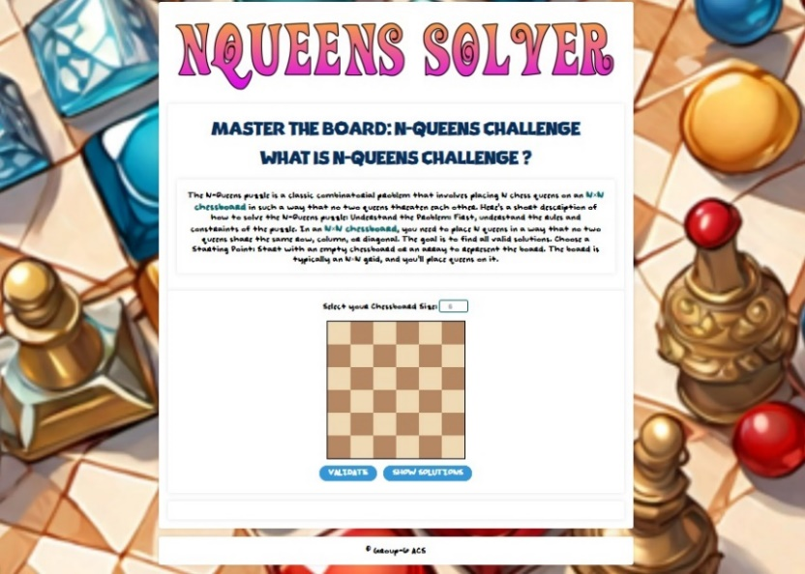

**Figure 1**

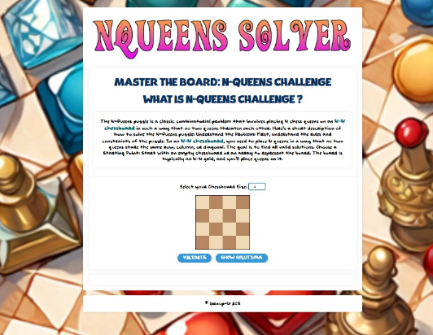

**Figure 2**

|  |  |  |  |
| --- | --- | --- | --- |
| S.No. | Test Case | Expected Result | Results |
| 3 | To test the validation of solution presented to user | **Case 1**: Display pop up to the user if the validation of their solution is correct. | Results are presented in [Fig-3] |
|  |  | **Case 2**: Display pop up to the user if the validation of their solution is incorrect. | Results are presented in [Fig-4] |

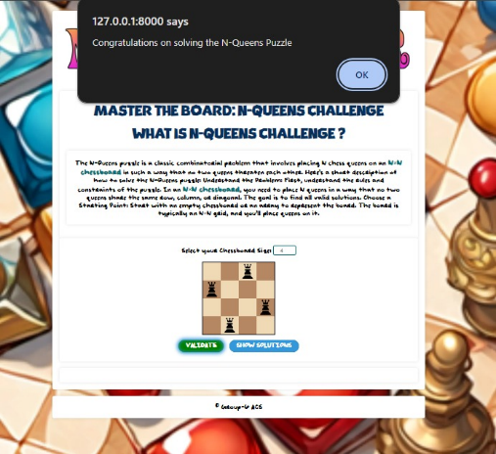

Figure 3

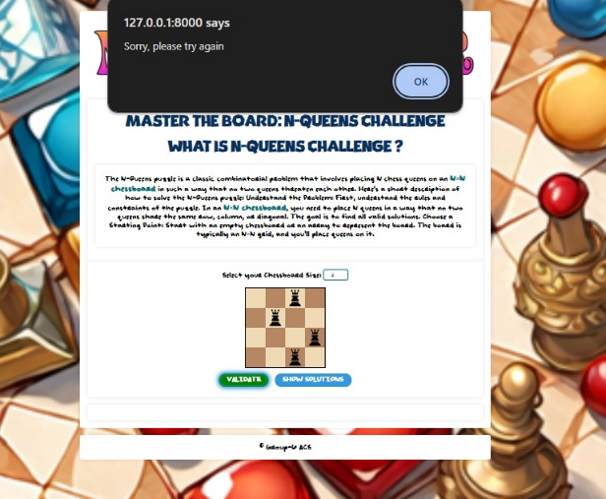

**Figure 4**

|  |  |  |  |
| --- | --- | --- | --- |
| S.No. | Test Case | Expected Result | Results |
| 4 | To test placement and removal of Queen Pieces by clicking. | First click on chessboard should place the Queen piece on that position and Second Click on the Queen piece should remove the said piece. | Each expected action is performed successfully.  [Fig-5][Fig-6] |

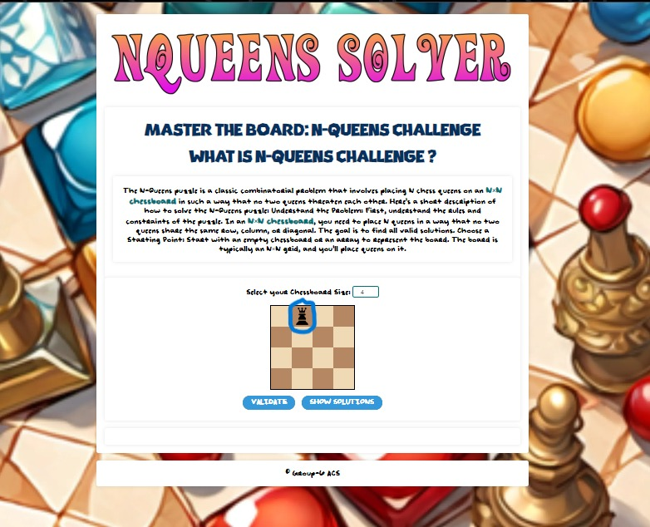

**Figure 5**

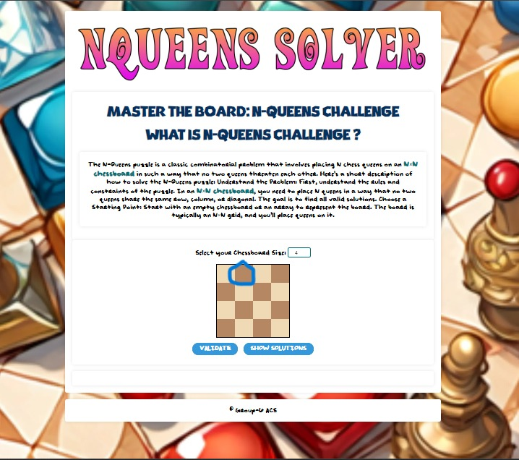

**Figure 6**

|  |  |  |  |
| --- | --- | --- | --- |
| S.No. | Test Case | Expected Result | Results |
| 5 | To test the number of Queen pieces placed is not more than the corresponding size of the Chessboard. | To ensure if user attempts placing Queens more than the size of the Chessboard, an error pop up is displayed to the user. | The user is displayed the error pop up message as expected.[Fig-7] |

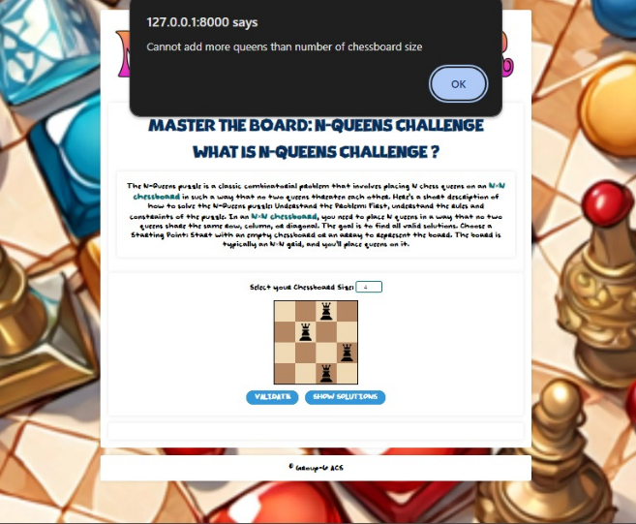

**Figure 7**

|  |  |  |  |
| --- | --- | --- | --- |
| S.No. | Test Case | Expected Result | Results |
| 6 | To verify the accuracy of the presented solutions | Accurate solutions are displayed after clicking “Show Solution” button according to the partially filled or empty chessboard and solutions are hidden after clicking “Hide Solution” button. | The presented solutions are accurate as per the rules of the game.[Fig-8][Fig-9] |

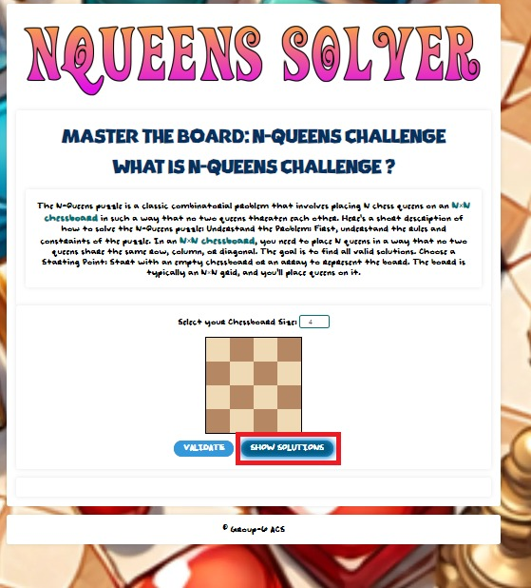

**Figure 8**

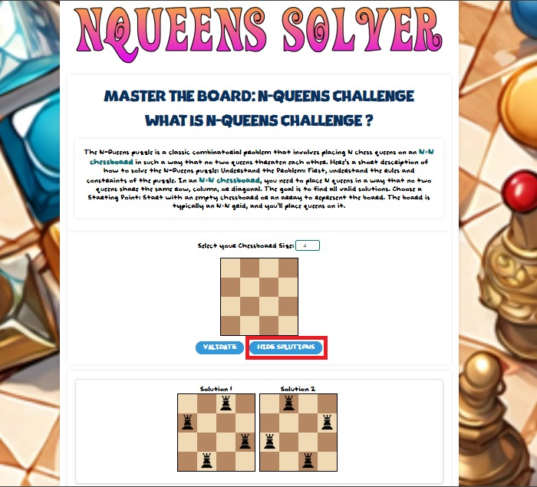

**Figure 9**

*Polysphere Puzzle-2D*

|  |  |  |  |
| --- | --- | --- | --- |
| S.No. | Test Case | Expected Result | Results |
| 1 | To test the successful launch of Polyshpere Puzzle -2D Server | Successful Launch of Server | Server launched successfully.[Fig-10] |

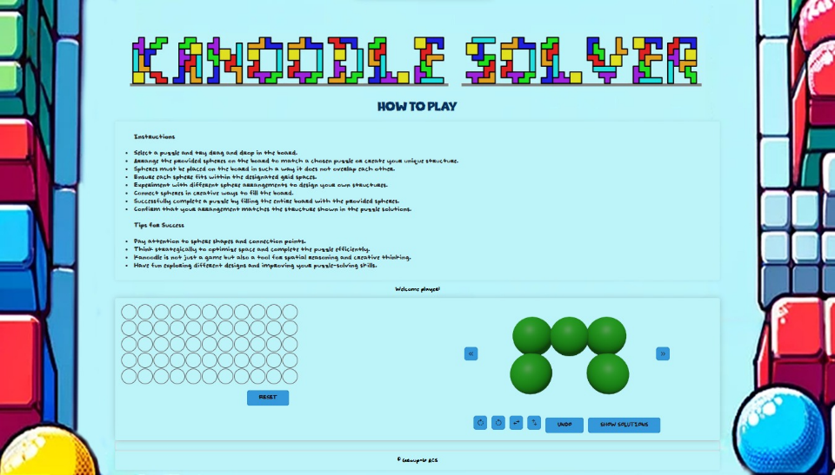

Figure 10

|  |  |  |  |
| --- | --- | --- | --- |
| S.No. | Test Case | Expected Result | Results |
| 2 | To test the placement of polysphere pieces into the board. | Accurate placement of the pieces by dragging and dropping polysphere pieces onto the board as per user’s expectation and removal of the last placed piece by clicking “undo” button. | Dragging and dropping action is as expected  [Fig-11][Fig-12]  as well as “undo” action.  [Fig-13][Fig-14] |

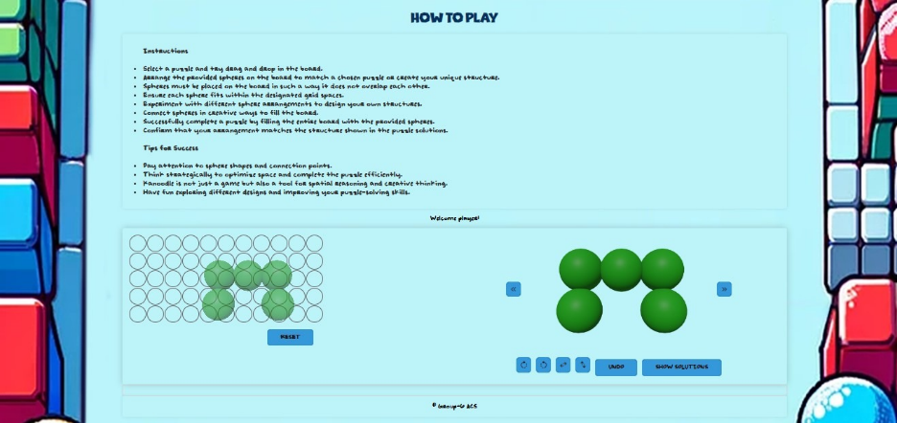

Figure 11

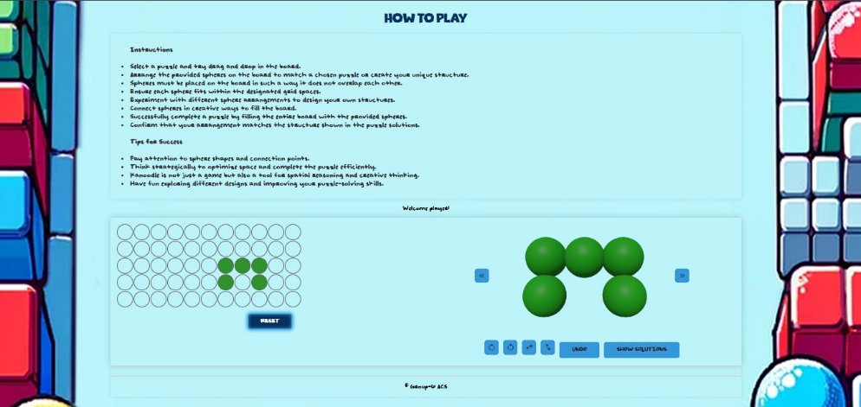

Figure 12

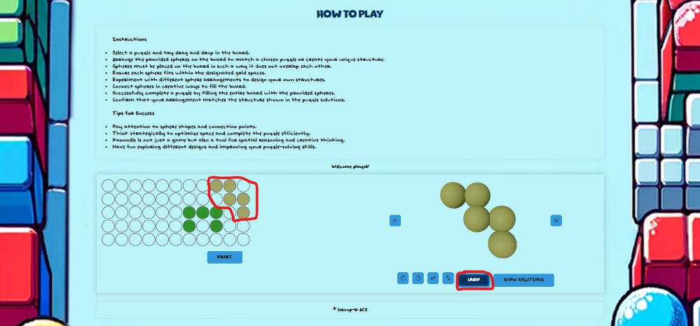

Figure 13

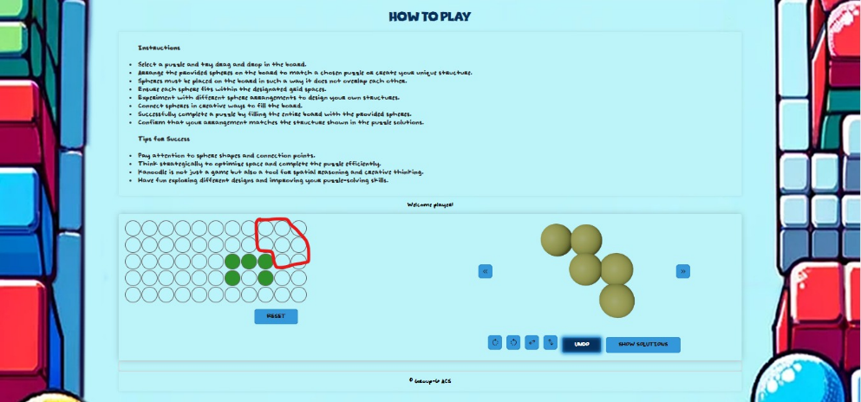

Figure 14

|  |  |  |  |
| --- | --- | --- | --- |
| S.No. | Test Case | Expected Result | Results |
| 3 | To test the accuracy of rotation and restructuring of the polysphere pieces using the provided buttons. | **Case 1**: Verification of left and right rotate symbol buttons.  90 degrees left or right Rotation of the polysphere pieces by click of each respective left or right rotate symbol button. | Button functions are as expected. [Fig-15][Fig-16]  [Fig-17] |
|  |  | **Case 2**: Verification up-down and side-to-side flip symbol buttons.  180 degrees’ flip of the polysphere pieces by click of up-down or side-to-side flip symbol buttons. | Button functions are as expected. [Fig-18][Fig-19]  [Fig-20] |

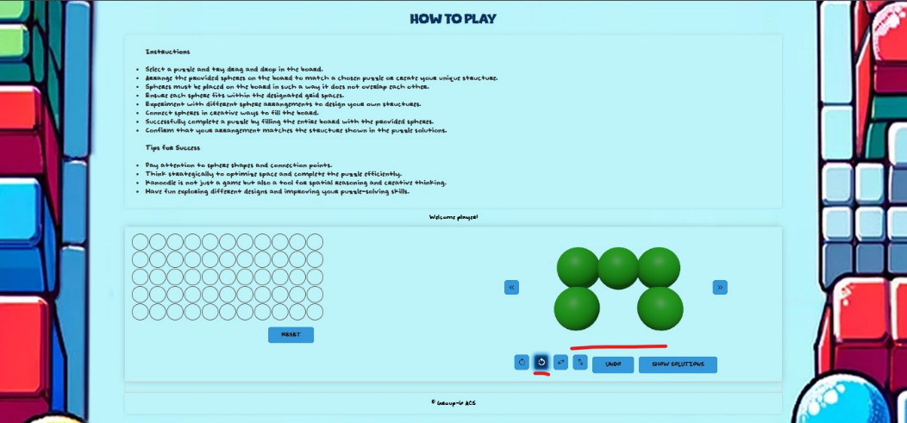

Figure 15

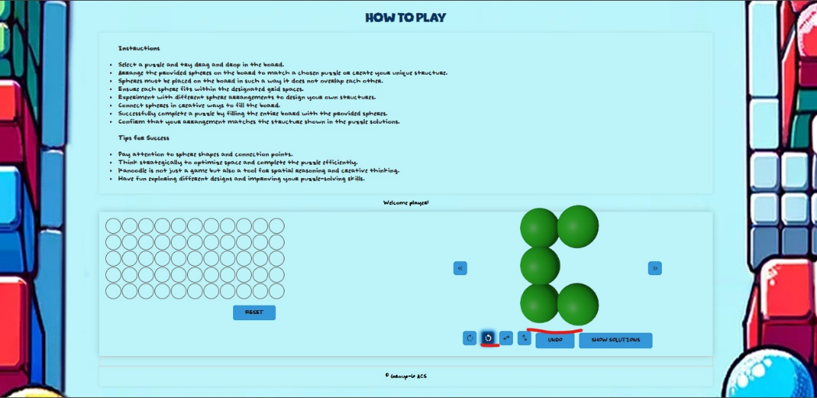

Figure 16

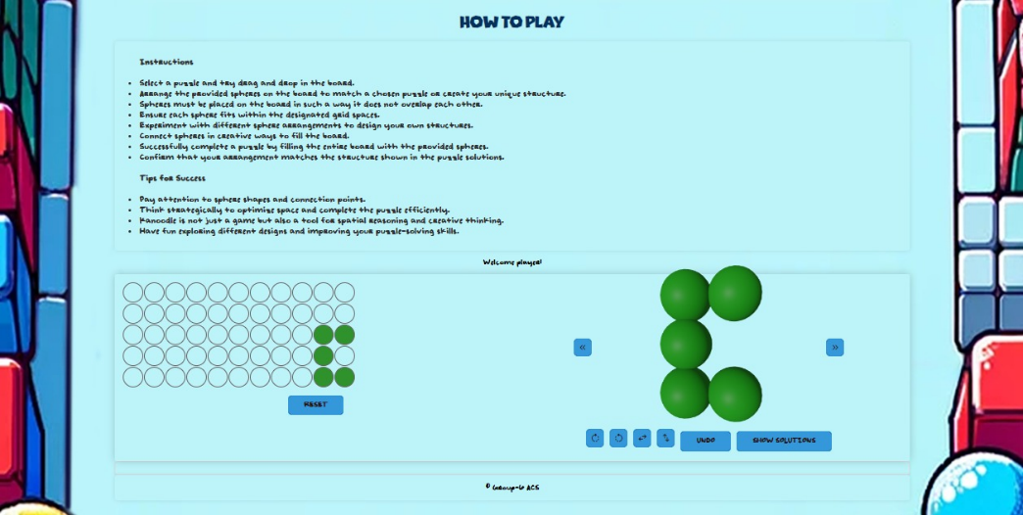

Figure 17

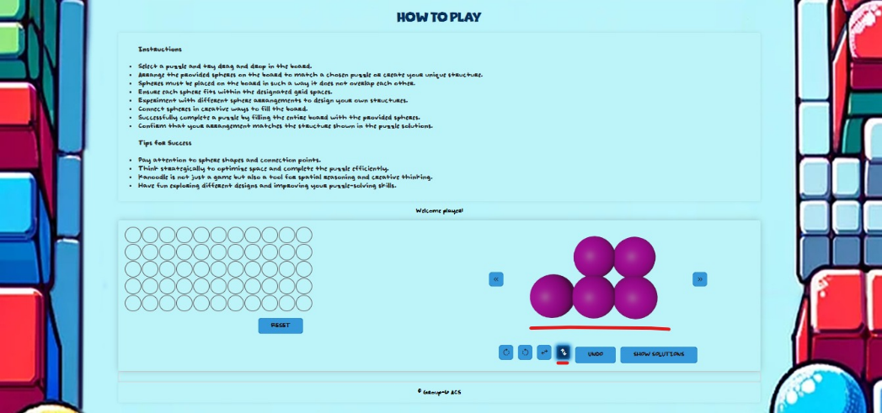

Figure 18

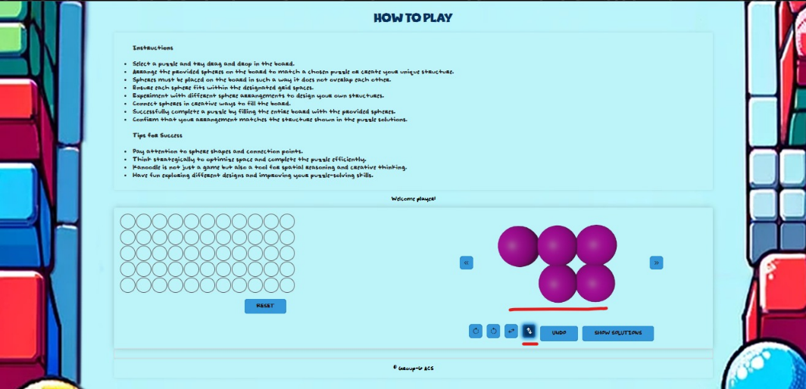

Figure 19

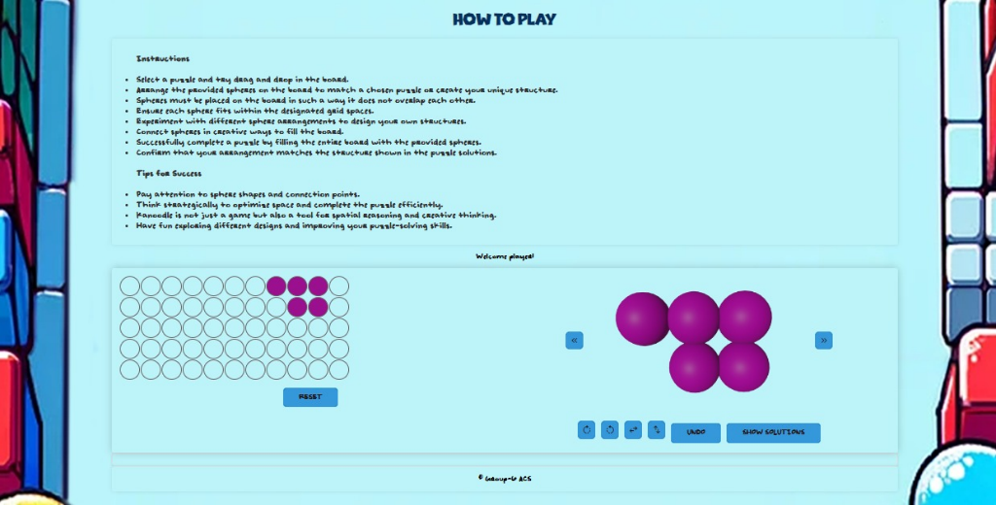

Figure 20

|  |  |  |  |
| --- | --- | --- | --- |
| S.No. | Test Case | Expected Result | Results |
| 4 | To test the accuracy of the presented solutions. | **Case 1**: To verify functionality of “Show Solution” Button  Solutions are displayed after clicking “Show Solution” button and in case of no possible solutions for user’s piece arrangement on board, a message is displayed | Button function is as expected. [Fig-21] |
|  |  | **Case 2**: To verify the accurate solution is presented. | Accurate solution is presented.[Fig-22] |

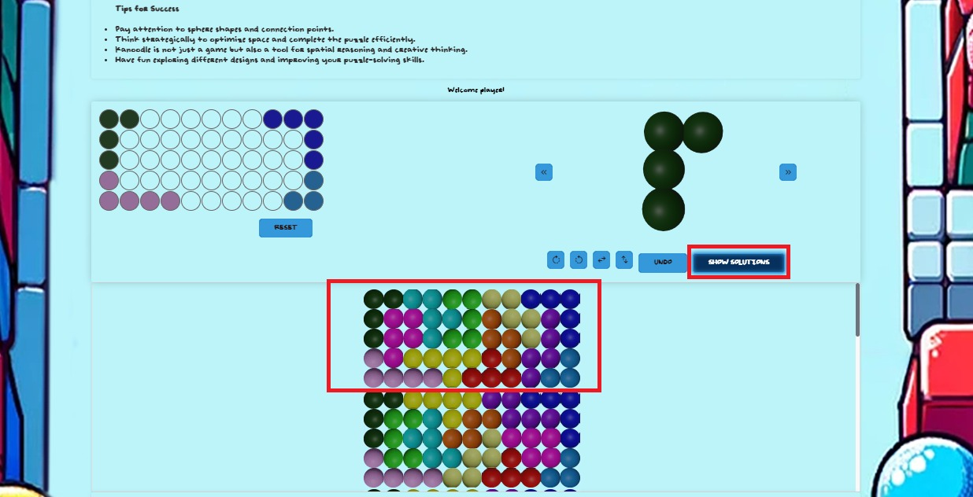

Figure 21

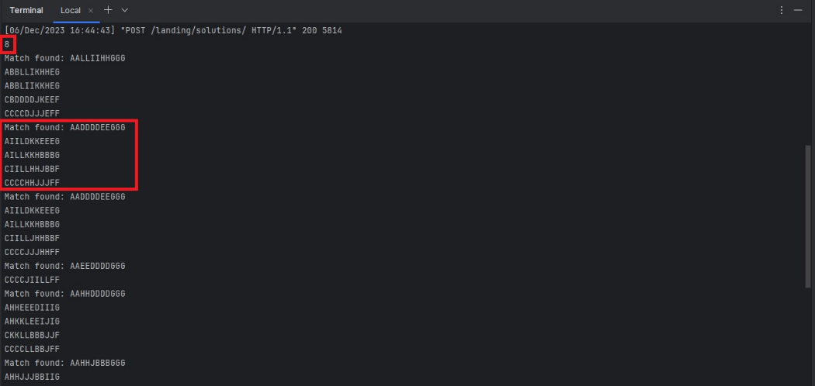

Figure 22

|  |  |  |  |
| --- | --- | --- | --- |
| S.No. | Test Case | Expected Result | Results |
| 5 | To test the Reset button | The “Reset” button should clear all the pieces from the board. | Button function is as expected. [Fig-23][Fig-24] |

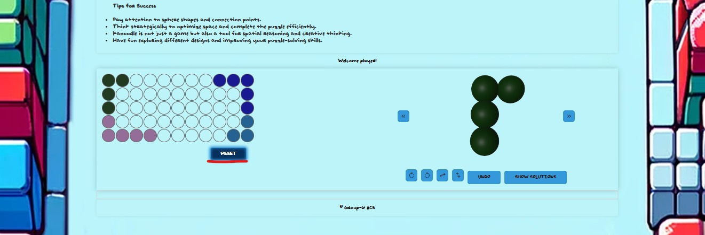

Figure 23

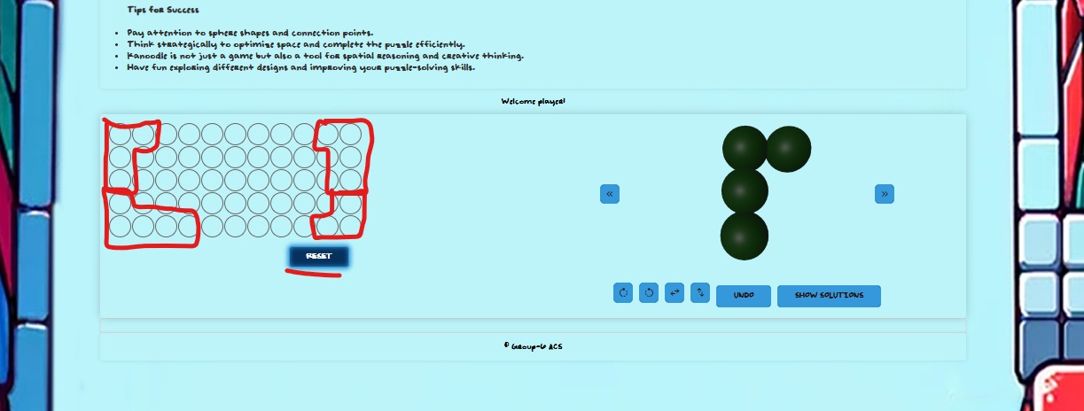

Figure 24